**Test Cases**

**Feature**: Run the file

**Scenario**: Run the file

Given I have the sistema.py file

And I open the terminal where the file is inside

When I write “python3 sistema.py”

And I press “Enter”

Then the terminal opens up the file showing the login interface.



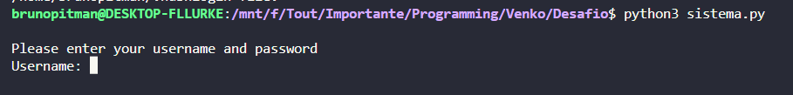

**Feature**: Test login inside the file

**Scenario01**: Logging with the wrong credentials

Given the terminal is running sistema.py

When I write the wrong login or password

Then the terminal shows “The username or password is incorrect”

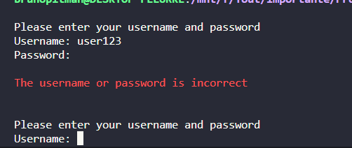

**Scenario02**: Logging with the right credentials.

Given the terminal is running sistema.py

When I write “admin” for username and password

Then the system shows the message “Login Success”

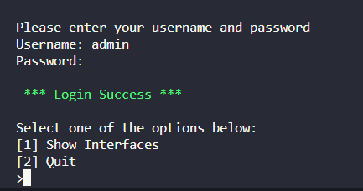

**Feature**: Options after “login success”

**Scenario01:**Selecting “Show Interfaces”

Given I logged in

When I press “1” for “Show Interfaces”

Then the system will show the table with all the ips and connections in your computer

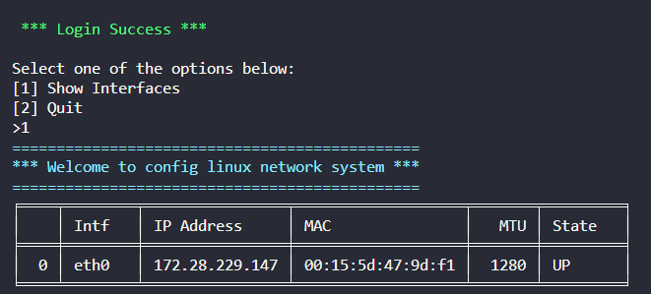

**Scenario02**: Selecting “Quit”.

Given I logged in

When I press “2” for “Quit”

Then the system ends the current file

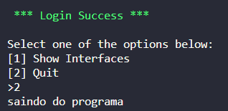

**Scenario03**: Selecting Other option besides the actual two

Given I logged in

When I press a key Other than “1” or “2”

Then the system shows “Command not accepted” and asks to press one of the options before

